**Hearing Aid System for The Hearing Impaired**

**Using a Power Amplifier**

**Project Proposal**

**Problem**

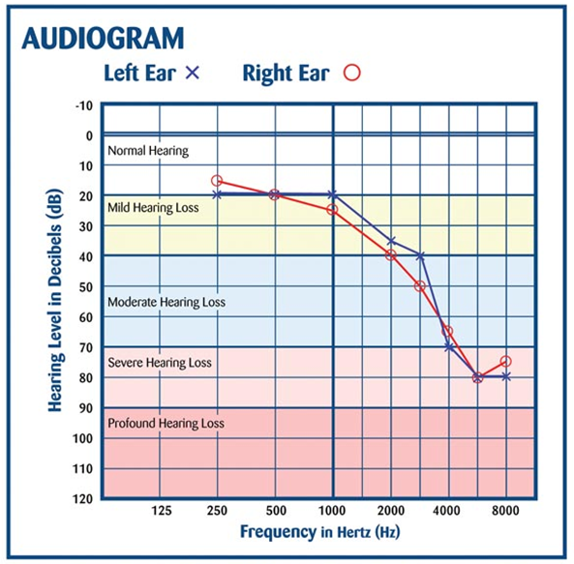Hearing disabilities are a common physical disability in modern society. Some of these disabilities are permanent and non-recoverable. The only recoverable hearing loss using an external assistance is sensorineural hearing loss. Ears of patients with SNHL are non-responsive for some frequency ranges. In other words, hearing threshold of some frequencies are high. This characteristic function is unique for a patient and it is known as the audiogram. An example for an audiogram is shown in figure (1).

figure (1)

**Objective**

In this project we will try to implement a hearing aid using a power amplifier circuit. The aim of the hearing aid to amplify the input audio signal to relax the job of the damaged auditory system. Also, we will try to control the loudness of the output audio signal so loud input audios will not make a too loud output signal.

**Approach**

The input transducer, microphone will take the signal from the environment and convert it to an analog electrical signal. The pre-amplifier will amplify the voltages so that small or undiscoverable voltages can also be detected precisely. Next the signal will be sent through an active low pass filter. Thus, the audible range, up to 20 kHz can be filtered. Then the amplitude compressor will prevent the signal from exceeding a desired power of the signal. In essence it will prevent the loud audios of not being too loud and will take the soft audios up to a medium standard. Next the power of the complete signal will be amplified using a class AB amplier. Finally, the output will be given through a high impedance speaker. The following block diagram depicts a summary of the process.

**Block Diagram**